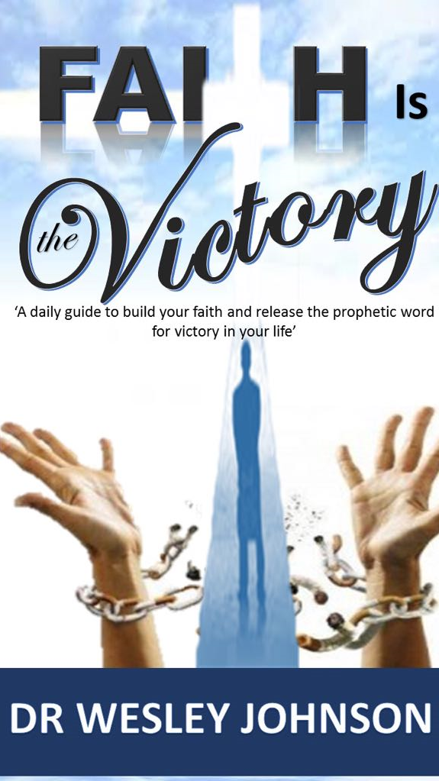

My Appreciation
I want to personally thank Pastor Alex Omokudu Pastor of Victorious Pentecostal Assembly for His counsel, His prayers and support, who stood by me through some of the most difficult times in my life and ministry. Pastor Alex has had a profound impact on my life and I will be forever grateful to God for Him.
I also want to thank Pastor Audrey, Pastor of The New Arc Ministry for Her continual encouragement and invaluable assistance in the writing of this book. She is a great leader and a wonderful gift to the body of Christ.

Table of Contents
Page
Foreword 4
How to Use this Book 5

Introduction 6

Chapter

- The Faith Connection 8
- The Place of Faith 26

- Three Kinds of Faith 39

- Violent Faith 58

- Satan’s Focus and Attack 77

- Testimonies of Faith 92
Foreword
Many books have been written, and many sermons have been preached on the subject of faith, but what makes this book stand out, is that ‘Faith Is The Victory’ gives you an in-depth understanding of the inner workings of faith.

As you follow the instructions in this daily guide, make your personal decrees and receive the prophetic declaration made by Dr. Wesley Van Johnson, you will be blessed. You will start to see your faith strengthened, and at the same time, receive the activation and manifestation of results for greater victory and your story will change.

Your Time Has Come!

Pastor Alex Omokudu
Victorious Pentecostal Assembly.

How to Use this Book
This book has been written as a guide to spark your faith and encourage you to pursue your God given purpose. Take time to read this book, chapter by chapter, week by week, once a month for twelve months. At the end of each chapter you will find both my Prophetic Instructions and your Personal Declarations. As you receive and believe my prophetic instruction and make your personal declaration, YOUR story will change and your life will never be the same. ‘YOUR TIME HAS COME!’
Remember, If You Need Prayer, I Care! Please forward your prayers requests to:
drwj78@gmail.com Matthew 18:19 Amplified.
For Conference or Revival bookings contact Dr. Johnson at: drwj78@gmail.com

Introduction
Faith is the Victory

If the Bible says you cannot overcome without faith, it means you cannot overcome without faith. If it says you cannot please God without faith it means you cannot, it does not matter how hard you try.
The Bible expressly teaches the place of faith – that faith is a vital weapon, a shield that wards off the devil's arsenal. The Bible says faith is the key to grace– no faith, no salvation (Ephesians 2:8). The Bible says faith is the way to please God. And again it says no faith, no testimony (Hebrews 11:5-6). Faith can turn what you hear into a blessing (Romans 10:17). Faith can turn what you speak into a miracle (Matthew 21:21).
Why does the Word speak so much about faith? Because faith is the key to the supernatural. Faith is the Key to victory. “This is the victory that overcomes the world, even our faith” ( I John 5:4).
As you read about and learn how to operate faith, how to exercise it and how to walk by faith, I pray your life will go from 1 degree of victory to another.

Dr. Wesley Van Johnson

Chapter 1
THE FAITH CONNECTION

“Now Peter and John went up together into the temple at the hour of the prayer, being the ninth hour. And a certain man lame from his mother's womb was carried, whom they laid daily at the gate of the temple which is called Beautiful, to ask alms of them that entered into the temple; Who seeing Peter and John about to go into the temple asked an alms. And Peter fastening his eyes on him with John said, Look on us. And he gave heed onto them, expecting to receive something of them. Then Peter said, Silver and gold have I none but such as I have give unto thee: In The Name Of Jesus Christ of Nazareth rise up and walk. And he took him by the right hand, and lifted him up and immediately his feet and ankle bones received strength. And he leaping up stood and walked and entered with them into the temple he leaping up stood and walked and entered with them into the temple walking and leaping and praising God" (Acts3:1-3). (KJV)

Somewhere between Peter and this lame man there was the faith connection. Faith has to connect like a hook. If you let down your fishing line into the sea, with a baited hook and it doesn’t connect with a fish you will know. If it does connect, and the fish is hooked to the line, you will also know. It just feels different. It feels heavy because there is something hooked to it. You can feel the pull and the struggle as the fish fights to free itself from the connection. A fisherman does not need to see the fish to know it has made a connection.

The lame man in Acts 3, had a need and Peter had the faith to bring about the lame man’s deliverance. Faith was the necessary connection. In the spiritual realm, faith is what makes the connection to your victory!

Faith makes the difference! Verse 5 says, "He gave heed unto them expecting to receive something of them.” And in Verse 6, Peter said, "… but such as I have give I unto thee...” This lame man gave heed with such expectation and Peter, a believer, full of faith, declared the Word with such authority that is a recipe for a miracle.

In verse 1, Peter and John were on their way to pray and to hear from the Lord. You could say that Peter and John were prayer partners and you would be right. We need prayer partners. We need people who pray and stand together in agreement. Peter and John stood together in agreement for the lame man. "Can two walk together except they be agreed?” (Amos 3:3)(KJV). There is something about agreement that makes faith work. That is why Jesus said in Matthew 18:19, “ … If two of you shall agree on earth as touching anything that they shall ask, it shall be done for them …” Agreement makes faith active.

The healing of the lame man was not planned. It was not rehearsed. It just happened as the parties involved walked in faith and belief. Faith is not rehearsed; it is spontaneous when a believer lives by faith. You just know when victory is yours! Peter and John knew this as they entered the Beautiful gate on their way to worship. There were all these beggars accosting the worshipers. They were begging for a little dime or a quarter.

Usually, this is how one knows a beggar; beggars always ask for small insignificant amounts that cannot satisfy. Someone may be carrying a bag of money past them, they still would not ask for anything but a dime or a quarter. You won't even see a beggar ask for a thousand dollars; it is way too much for his poor spirit. If you had five thousand dollars on you and someone came up to you asking for five thousand dollars, you can be sure he is not a beggar. He may be an armed robber, but certainly not a beggar. Beggars always ask for those little favours that will not make much of a difference.

Sadly, there are many beggars in the family of God. These are people who are entitled to great blessings but they do not have the boldness to enter the greatness of the realms of faith and ask for what they need. They are timid even after the writer of Hebrews says, to come boldly to the throne and find grace to help in the time of need (Hebrews 4:16).
The hymn writer, John Newton said:

Thou art coming to a King,
Large petitions with thee bring;
For His Grace and power are such,
None can ever ask too much.

Boldly ask what you want from God: you can never ask too much!

Beggars hate to ask for something that will really meet their needs. They don't want to bother God with their problems. No, they don't want to bore God with their real needs. So even when they do ask, they only ask for those little bitty things that won't meet their needs. That is the beggar syndrome.

In verse 3, the lame beggar was asking alms of Peter and John. He was asking for a few coins. He figured that if he got a little here and a little there and added it all together, he may just get by for the day. But God was actually saying, "Ask that your joy may be full.” John 16:24
That is the reason for asking, ladies and gentlemen – for the fullness of joy. This beggar did not know this. Peter and John had to drive it home to him.
“Look on us,” Peter said. This was a rather unusual procedure in this trade. Usually, beggars do not go into dialogue with their benefactors. They ask for quarter. You drop a dime or two. You move on. Thank you, that's it. No dialogue. But Peter said, “Look on us!”

This was the key to this miracle; Peter heightened this beggar's expectation. He took his faith beyond the dime and quarter limit. Peter caused this beggar's expectation to soar beyond the usual level. He helped this lame man's expectation to go higher than his original petition. Your expectation must soar higher than usual so that your petition can soar high enough to meet your whole need and not part. You must expect greater because .. “God is able to do exceedingly abundantly above all that we ask or think…" (Ephesians 3:20).
“Look on us!” And the beggar looked. The Bible says, "He fastened his eyes…" This was the expectant look. This was the intense focus of faith - expecting to receive something more!

When this man first accosted Peter and John he wasn't sure of anything. Both of them looked like fine gentlemen, yes, but that was all he could say about them. The business of begging is full of uncertainties. They were some perfectly nice-looking worshippers who may, or may not have given money to them, but these beggars asked everybody regardless. Now, here came Peter and John saying, “Look on us.” So the lame man looked expecting something; something was about to connect. And if it's going to connect, that look of faith must be there. Expectation must be there.

While the lame man looked, Peter released the supernatural. He ignited the dynamite and let it go. In verse 6 and 7, we see Peter, by faith, taking the lame man’s hand, declaring that he would walk, he pulls him up to his feet. Faith is like dynamite, it will not explode unless it is first ignited by word and action. Like a grenade, it won't explode and change an environment unless it is released into your circumstances.

26 For as the body without the spirit is dead, so faith without works is dead also (James 2:26)

This lame man had expectations but I don't know if he had all the faith he needed to get started or not. But I see Peter giving him a helping hand. And I see the man having enough faith to surrender to Peter’s helping hand and taking his very first steps.

The supernatural is like a gun and the tongue is the trigger? The supernatural is released by your bold declaration. That is why New Testament praying is more of a declaration than petition. There was a connection between the beggar's expectation and Peter's declaration.

Hear Peter's declaration. “Silver and gold have I none but such as I have give I unto thee…” (Act 3:2). I can see the perplexed look on this lame man's face. I can see the anger and the frustration. This was not what he expected to hear. After all that “Look on us,” after all that dialogue, he expected a “Take this fifty dollar bill and buy yourself a good pair of pants.” Or maybe even twenty dollars. But certainly not that statement: “Silver and gold have I none.”

I am sure you know that silver or gold was what the beggar sat out there for. He wasn't there for the dialogue. He wasn't out there to make friends. He was there to get some money so that he could hopefully improve his situation. “Money answereth all things” and he wasn't the one that said it; it was Solomon in Ecclesiasties10:19. And because Peter said he didn't have the money to give, he must have been disappointed.

It is a pity that many Christians feel that way too. They think there is a certain amount of money that will solve all their problems. Some even get depressed because they don't have all the money they need. And they become so depressed they are not emotionally positioned to possess what they need.

I can hear this beggar grumbling to himself, “You made me stop to look on you expecting to receive something; you took so much of my time. Now you're telling me you don't have the silver and you don't have the gold? What do you have then?” The beggar was expecting to hear the offer that Peter had, and hoped that it may improve his situation. “..such as I have, I give unto thee.” Here Expectation Meets Declaration.

I stand to tell you that there are things that you possess which may not show. It may not be obvious that you have them but you do. If you are a Believer you have His peace, that is a rare commodity in a troubled world. You have the joy of the Lord which is your strength. You have eternal life. It is stored and it is yours. You have hope, not only in this world but for hereafter. You have God's provisions and covenants and God is a covenant-keeper. What he promises, he will deliver. I can go on and on. It may not look like you have anything but you have so much, really.

Peter said, “Silver and gold have I none but such as I have I give unto thee.” Didn't I just tell you that it is not everything you have that shows? See here, Peter had that healing anointing and this man didn't even know it. When this lame man looked at Peter all he saw was whatever he was wearing, his height, beards, and, maybe, his tribal features. But Peter had something else; he had that faith and that anointing. How do we know?

Because he could exercise it spontaneously to the beggar’s condition. You cannot exercise what you do not have. If I can just get you to exercise your faith as a natural response, you would be surprised at how much you have. You have to exercise it. The faith that brings victory has to be exercised. Again, this is a hand grenade situation that I mentioned earlier. You have to unlock it to explode it. You have to release it to activate it. You have to exercise faith in order for your miracle to manifest. If I can just get you to exercise your faith as a natural response to life’s challenges, you would be unstoppable!

Peter was so sure of what he had in Christ and that it solved the lame man’s problem, God’s way. “This is what I have - In The Name Of Jesus Christ of Nazareth…” (Act 3:1-3).
The lame man received the hand of Peter and allowed Peter to pull him up and walk. He did not struggle, fight or resist. He wanted to be released from his situation. His expectations, combined with Peter’s faith, caused the lame man to take his first ever step. For the first time in his life, this lame man could walk.
This is the faith connection. If I can just get you to take your first step and exercise whatever measure of faith you have! If I can just get you to make that faith connection!

Prophetic Utterance: I decree and declare, that today as you read this chapter, your faith is releasing and your expectations are rising. Greater opportunities are now coming your way. Right now, boldly declare God’s word over your situation.
Dr. W Johnson

Declaration: I decree that the beggar syndrome is broken off my life and the life of my family. My destiny helpers and prayer partners are locating me and will stand and agree with me for my victories. In Jesus Mighty Name

Chapter 2

THE PLACE OF FAITH

“Let us hold fast the profession of our faith without wavering; (For He is faithful that promised); And let us consider one another to provoke unto love and to good works: Not forsaking the assembling of ourselves together as the manner of some is but exhorting one another and so much the more as ye see the day approaching“(Hebrews 10:23 -25) (KJV).

The greatness that is being birthed in you, will require a key ingredient to bring it to fruition. That is abiding faith, staying in the place of faith by standing on the word.

There is a place of faith that no matter your challenges, no matter your opposition or the degree of the attack, you will not be moved or shaken.
“.. none of these things moved me” (Acts 22-24)

God has given to every man a measure of faith (Romans 12:3). Yet for faith to grow, it must be cultivated, worked on, nourished, and exercised. Faith is something we must live by in our daily Christian walk. For Hebrew 11:6 says, “Without faith it is impossible to please God”.

We all know what real faith can do. Jesus said in Matt 21:22, “Verily, I say unto you. If you have faith and doubt not, you shall say unto this mountain; Be thou removed and be thou cast into the sea, and it shall be done. And all things (not some things) whatsoever ye shall ask in prayer believing, ye shall receive.”

Faith is that important. Again, our entire Christian walk depends on faith. Faith moves the things we can't move naturally. Faith accomplishes what we cannot accomplish in the natural. Yes, faith is important and that is why it must be nourished. If one does not nourish or take care of one's faith, it is bound to wane and die.

Many of God's people have dead faith; they starved their faith to death. The Word of God says, “Faith cometh by hearing and hearing by The Word of God” (Rom 10:17). In order for you to be strong in faith, you must be fed adequately from The Word. You must read and gain an understanding of The Word. The Word is very essential, that is why David said,

“Thy Word have I hid in my heart that I might not sin against Thee” (Psalms 119:11). He also said “Blessed is the man that walketh not in the counsel of the ungodly, nor standeth in the way of sinners, nor sitteth in the seat of the scornful; but his delight is in the law of the Lord and in His law doth he meditate day and night” (Psalms 1:1-2).

The Lord gave us His Word to help us abide in the place of faith. John 15:7. This is why you must know The Word. We need The Word to overcome the devil. You know the devil will come. I am sure you do not need a preacher to tell you that. The devil infiltrates into everything. He came to Jesus even in the midst of a fast, remember? Matthew 4:1-11.
4 Then was Jesus led up of the Spirit into the wilderness to be tempted of the devil. 2 And when he had fasted forty days and forty nights, he was afterward an hungred. 3 And when the tempter came to him, he said, If thou be the Son of God, command that these stones be made bread. 4 But he answered and said, It is written, Man shall not live by bread alone, but by every word that proceedeth out of the mouth of God. 5 Then the devil taketh him up into the holy city, and setteth him on a pinnacle of the temple, 6 And saith unto him, If thou be the Son of God, cast thyself down: for it is written, He shall give his angels charge concerning thee: and in their hands they shall bear thee up, lest at any time thou dash thy foot against a stone.7 Jesus said unto him, It is written again, Thou shalt not tempt the Lord thy God.8 Again, the devil taketh him up into an exceeding high mountain, and sheweth him all the kingdoms of the world, and the glory of them; 9 And saith unto him, All these things will I give thee, if thou wilt fall down and worship me.10 Then saith Jesus unto him, Get thee hence, Satan: for it is written, Thou shalt worship the Lord thy God, and him only shalt thou serve.11 Then the devil leaveth him, and, behold, angels came and ministered unto him (KJV)
In verse 4, Jesus was on fasting and was hungry and the tempter came to tempt him to perform a miracle of creating food out of stones. This would be an act that was out of God’s timing and God’s will. If the enemy cannot get you to hold back on God, he will try to get you ahead of God, to move before it’s time to move. There is a place in God where your patience will stand only by faith.

In verse 5 and 6, the enemy attacks Jesus concerning His identity; v6 ‘…if you be the son of God ..’. He had already been declared as the son of God prior to entering into the wilderness and now the enemy is challenging Him concerning this identity. There are many in the body of Christ that have an identity crisis. When struggles, tragedy, trials and temptation come, the enemy whispers in their ear, where is your God? The enemy tries to rob us of our sonship identity and dominion, also of our authority to speak and stand in faith, by shaking our confidence in God through various attacks. This sometimes leads many to move from the location of faith to a place of unbelief and to take up the identity of the world and its characteristics of fears, doubts etc.

In verse 9 Jesus was challenged to abort God’s plan for His life and to no longer put God first and to worship another. The enemy tempted him to choose wealth, riches and instant gratification to please His flesh more than His God.
There is a place in faith where nothing shall separate you from the love God. Romans 8:38 - 39. God needs to sit on the throne of our life and have first place for us to stay in victory.

Jesus used The Word and His faith in all these temptations and he overcame.

Now imagine what would have happened if Jesus didn't know The Word! Jesus would have failed and His mission would have been aborted.

Of course, you know you cannot tell the devil, "I am Jesus, don't tempt me.” You cannot say, "Devil, leave me alone: I am a Christian.” He knows you are a believer that is actually why he comes.
James 15:20 ‘Remember The Word that I said unto you, The servant is not greater than his lord. If they have persecuted me, they will also persecute you; if they have kept my saying, they will keep yours also.
(KJV)

The devil knew that Jesus was who He was; he knew Jesus as the Son of God before he came to tempt Him. He actually prepared especially for Him. But thank God, Jesus had The Word. And he declared The Word of God to the tempter.

Jesus took the devil back to The Word and said, “It is written". If you are going to have victory over the devil, you have to read and know The Word. It is a weapon of offence and with it, we can beat the devil anytime.

One other thing: You must believe The Word for "all things are possible to him that believeth” (Mark 9:23). Not only did Abraham know God's Word, he believed it and staggered not at the promises of God. When the Lord spoke to Abraham, he believed it and stood on it. This is the kind of faith that calls the things that be not as though they were – even before they come into existence (Romans 4:17).

You must know The Word, believe The Word, and then stand firm on The Word. Apostle Paul says, “After we have done all, we are to stand. We have to stand. We have to be fully persuaded that God would do what He said He would (II Timothy 1:12) Stand on The Word.

Now, I want you to understand further that in the place of faith, knowing The Word by reading, meditating, and revelation by the Holy Spirit; sharing and teaching; through having a local Pastor and a home church, where The Word is rightly divided, is only the first step. Believing and standing on The Word is also necessary but The Word must also be exercised by acting on The Word. It is not the hearer that is justified, it is the doer (James 1:22-23). The Word says, “ yea, a man may say, thou hast faith and I have works: shew me thy faith without thy works, and I will shew thee my faith by my works” (James 2:18).

A believer that knows The Word must be a doer of The Word. You must work it practically, operate it daily, and demonstrate it powerfully. As a Child Of God, you must live holy, stay in fellowship, fast, pray, tithe, witness, work out your own salvation and God will do His part. When you step out in faith, believing The Word, God will not let you down. Trust in the Lord and you will eat the good of the Land. When you lay your all on the altar, it will be covered by the fire of God. Only what you lay on the altar does the fire consume! You have to willingly give your all to the Lord and lay your all on the altar. Then God will make a way, where there seems to be no way. Matthew 4:11 “11 Then the devil leaveth him, and, behold, angels came and ministered unto him “ (KJV)

Prophetic Utterance: Today as you read this chapter, I decree and declare that you will not be stagnant in any area of your life, you will flourish in Jesus name! Right now, boldly declare The Word over your life!
Dr. W Johnson

Declaration: I decree and declare, I abide under the shadow of the almighty God. I will not move location from the place of faith. Every attack mobilised to shake my faith, to abort God’s assignment for my life, is hereby rendered null and void, right now! In Jesus Name.

Chapter 3

THREE KINDS OF FAITH

Faith is such a vast subject I do not know one book that can exhaust all of its attributes – from common faith, saving faith, dead faith, great faith, too little faith and much more. So I am going to dwell on three special kinds of faith that lead you to your personal victory:

- Touching Faith
- Spoken Faith
- Wrestling Faith

(1) TOUCHING FAITH:
“And a certain woman which had an issue of blood twelve years and had suffered many things of many physicians and had spent all that she had and was nothing better but rather grew worse, when she had heard of Jesus, came in the press behind and touched His garment. For she said, ‘If I may touch but His clothes I shall be whole.’ And straightaway, the fountain of her blood was dried up and she felt it in her body that she was healed of that plague” (Mark 5:25-29) (KJV).

Here is a lady that doctors could not help. Every time she went to the physician, all they would do is take her money and give her the same report. They could not heal her. Then one day, a new doctor came to town. She heard the reports of the blind eyes opening, the deaf ears hearing, and even the dead being raised and she said, “If I can just get to this new doctor, Jesus, all I need to do is touch Him.”

Although we know that we walk by faith and not by sight and that Faith is the evidence of things not seen (Hebrews 11:1). Many of the major miracles recorded in The Word of God, occurred through physical contact with either a person or an item. Of course, God does not need physical or natural means to accomplish his work. Yet we live in the physical realm and often times God uses people or things around us to inspire our faith. He even uses natural things to convey spiritual truths so as to give us greater revelation of His Word.

God has designed it that touching is a natural way of exchange and communicating and He uses level we are on in the natural to release the supernatural.

This woman was at a desperate place, her natural effort of touching His garment was all she felt she needed to do. She demonstrated her faith visibly but spiritually it brought about a supernatural release in the spirit realm “For she said within herself, If I may but touch his garment, I shall be whole...” Matthew 9:21

You see, that is Touching Faith. “If I just get to touch Him, I know I am going to be whole.” Often times you need to do something in the natural to initiate your breakthrough or your miracle. This is where a point of contact is important. Acts 19:11- 12
“11 And God wrought special miracles by the hands of Paul:12 So that from his body were brought unto the sick handkerchiefs or aprons, and the diseases departed from them, and the evil spirits went out of them.”

Touching Faith makes a man whole - at a touch. Touching Faith can change a situation - at a touch. And Touching Faith can reverse an adverse condition - at a touch. All it takes is a touch. No matter the severity of your condition, touching faith demands a determination to use whatever strength you have left to rise up and reach out.

“When Jesus departed thence, two blind men followed Him crying and saying, ‘Thou Son of David, have mercy on us’. And when He was come into the house, the blind men came to Him and Jesus and said to them, ‘Believe ye that I am able to do this?’ And they said unto Him, ‘Yes, Lord’. Then touched He their eyes saying, ‘According to your faith, be it unto you’” (Matt 9:27-28).

These two blind men knew if they could just get Jesus to touch them, they would be made whole. Blind Bartimaeus also knew that if he could get Jesus’ attention and be touched he would be healed. He knew it – he just knew it! (Mark 10:46-52).

The ten lepers knew if they could get to Jesus and have Him lay hands on them, they will be cleansed from their leprosy (Luke 17:12). The people knew that if Peter’s shadow could just touch them, they would be made whole. All this is Touching Faith. (Acts 5:15)

The book of James 5:14 said, "Is there sick among you, let him call for the elders of the church and let them pray over him, anointing him with oil in the name of the Lord.” That is Touching Faith. Touching faith says, “If two of you shall agree on earth as touching anything that they shall ask, it shall be done for them of my Father which is in Heaven.” (Matthew 18:19) Touching Faith brings a definite change in circumstances - at a touch!

(2) SPOKEN FAITH:
“And when Jesus entered into Capernaum, there came unto Him a centurion beseeching Him and saying, ‘Lord my servant lies at home sick of palsy, grievously tormented’. And Jesus said unto him, ‘I will come and heal him’ (He said I will just come and touch him and pray for her). The centurion said, ‘Lord, I am not worthy that You should come under my roof but speak the Word only and my servant shall be healed. For I am a man under authority having soldiers under me and I say unto this man, ‘go’ and he goes and to another, ‘come’ and he cometh, and to my servant, ‘do this’ and he does it. And when Jesus heard it, He marvelled and said to them that followed him, "I have not found so great faith, no, not in Israel…” And Jesus said unto the centurion, ‘Go thy way, and as thou hast believed, so it be done unto thee’. And his servant was healed in the self same hour” (Matthew 8:5 - 13). This is Spoken Faith.

As a Child Of God, you have power with God. There is an authority that you have as a Believer. That authority is in The Name Of Jesus and you can stand up and say, " In The Name Of Jesus, devil, loosen your hold.” There is no distance in the spirit realm, all you need to do is to speak The Word as one with authority. You can exercise your faith and say, "devil, you are a liar, you've kept this door shut long enough; now let it go! Enough is enough!” you can send The Word as far as you want. Just speak it and it will go forth, across countries, cultures, conditions and circumstances etc. and it will accomplish that which you have spoken. This is Spoken Faith.

“Then Jesus went thence, and departed into the coasts of Tyre and Sidon. And, behold, a woman of Canaan came out of the same coasts, and cried unto him, saying, ‘Have mercy on me, O Lord, thou son of David; my daughter is grievously vexed with a demon.’ But he answered her not a word. And his disciples came and besought him, saying, ‘Send her away; for she crieth after us’. But he answered and said, ‘I am not sent but unto the lost sheep of the house of Israel.’ Then came she and worshipped him, saying, ‘Lord, help me.’
But he answered and said, ‘It is not meet to take the children's bread, and to cast it to dogs.’
And she said, ‘Truth, Lord: yet the dogs eat of the crumbs which fall from their masters' table.’ Then Jesus answered and said unto her, ‘O woman, great is thy faith: be it unto thee even as thou wilt.’ And her daughter was made whole from that very hour. (Matthew 15:21-28).

This is Spoken Faith. Spoken Faith lets you send forth The Word - even without a touch.

Jesus spoke The Word at Lazarus’ tomb and he arose (John 11:43,44). He said “Lazarus, come forth!” And he did. He didn't have to crawl into the tomb to touch the rotten body. Before this time Mary and Martha sorrowed because Jesus was not there. They said, “If Jesus had been here to touch our brother, he would not have died!” But, you see, Jesus did not have to touch everybody. There comes a time when you have to stand your ground and just speak forth The Word. Even when you cannot touch, you can speak The Word. Jesus spoke The Word and Lazarus got out of the grave. I believe if Jesus had not mentioned Lazarus' name specifically, all the dead in the graveyard would have risen! There is a power in the spoken Word. Speak The Word in faith, in Jesus’ name and you will see results. If you just exercise your God- given authority, you can put the devil on the run every time. God has given you power. (Luke 10:19)

Elijah was a man of like passion. He was the one who stepped out and said, "according to my word, there shall be no dew nor rain for these 3 1/2 years.” And God backed him up. He said, “according to my word” not even according to The Word of the Lord.” You can stand on The Word and speak it In The Name Of Jesus.

(3) WRESTLING FAITH:
There might be times when touching faith is not possible and the Spoken Word does not bring immediate results. At such times we must wrestle our way into victory.

Some people apply Touching Faith and they encounter obstacles. They speak The Word and meet with resistance. Then they give up. But, no, that is the time to wrestle. Faith still works. Paul said, “We wrestle...against Principalities and powers…” (Ephesians 6:12)

When Touching Faith does not scratch the surface, it is time to wrestle. When Spoken Faith falls on deaf ears, it is time to fight and wrestle against the opposing forces that are hindering the victory. (Daniel 10:13) That is why Paul said, “We wrestle ….” we have to; we do not give up that easily! We wrestle!

“And Jacob was left alone; and there wrestled a man with him until the breaking of the day. And when he saw that he prevailed not against him, he touched the hollow of his thigh; and the hollow of Jacob's thigh was out of joint, as he wrestled with him. And he said, ‘Let me go, for the day breaketh’. And he said, ‘I will not let thee go, except thou bless me’. And he said unto him, ‘What is thy name’? And he answered, ‘Jacob.’ And he said, ‘Thy name shall be called no more Jacob, but Israel: for as a prince hast thou power with God and with men, and hast prevailed’” (Gen 32:24-28). This is Wrestling Faith.

You have to wrestle, fight, be on the front line of the battle and win. You cannot afford to run because there is no provision for retreat. Daniel wrestled and held onto to the horns of the altar. He would not give up until his prayer was answered (Daniel 10:12). Take a hold of The Word and hold God to that Word. Daniel 10:12 Then he said to me, “Do not be afraid, Daniel, for from the first day that you set your heart on understanding this and on humbling yourself before your God, your words were heard, and I have come in response to your words (AMP).

Until the battle is over you cannot take a vacation. You wrestle. You have to throw yourself on the altar and say, "I know it is done according to Your Word. You said it and I believe it.”

There is a battle going on, the devil is trying to wrestle away your blessing but you say, "No, Devil". Then you grab with both hands and wrestle. Let the devil know that he cannot steal your blessings. "Whatever God has done is done forever, nothing can be taken away from it and nothing can be added to it." You have to hold onto your faith and wrestle.
Sometimes you might find yourself on the mat and it seems like the devil pinned you down. And the devil’s imp is standing above you ready to count you out. But in your heart you know there is still strength for another round!

You say, "hold it right there, devil; I can't stay down. I've come too far by faith to turn around.” And you start to move. The devil can't keep you down. Wrestling Faith has stepped in. God’s strength falls on you and you realise that when you are tried, you shall come forth as gold (I Peter 1:7). This is the heritage of the believer and their righteousness is of the Lord.

Wrestling Faith steps in to prevail over the enemy. Wrestling Faith will always put courage in your heart. Jacob had to wrestle for his blessing. If he did not wrestle, he would have lost it. You have to put up a good fight.

I want you to wrestle, stand strong, be courageous and fight in the good fight of faith. You are born to win, you are a warrior, a soldier of Christ. Go forth In The Name Of Jesus. If God be for you who shall be against you? Take on the whole armour of God and wrestle on to your VICTORY.

Prophetic Utterance: Today as you read this chapter, I decree and declare that you will rise up out of any area of your life that has left you in victim mode, anything holding up your success or standing in the way of your progress is moved now in Jesus name! Right now, boldly declare The Word over your life!
Dr. W Johnson

Declaration: I decree and declare, any plague or sickness that has crippled my life and my family’s life is broken today. I possess and walk in every quality and characteristics that allows me to touch and reach my success, Doors of favour open for me right now! In Jesus Name

Chapter 4
VIOLENT KINGDOM FAITH

“And from the days of John the Baptist until now the kingdom of heaven suffereth violence, and the violent take it by force.” (Matthew 11:12)

We need faith for our everyday struggles, but we also need faith to manifest the Kingdom of God on earth as it is in heaven. Matthew 6:10

In Luke 16:16 “The Law and the Prophets were proclaimed until John. Since that time, the good news of the kingdom of God is being preached, and everyone is forcing his way into it.” Luke 16:16 (NIV)

There is a violent attack against the advancement of the Kingdom of God. God needs those of us who are born again and as such are born of the Kingdom of God, to be used to advance the mission of the Kingdom here on earth as it is in heaven.

If you are going to make it as a Kingdom instrument, you must have violent faith. We are living in a time of spiritual sluggishness, a time of spiritual lethargy, a time when so many people have allowed the devil to take advantage of them.

So many of God's people are dragging their feet, looking like somebody beat them up. They look so discouraged and so full of fear. They are bound by so much unbelief. But as a Kingdom Child Of God in these last days, we must realise who we are in Christ.

Why are many believers running scared? Because they have been pushed to a corner. When they get up to testify, they say, "I want you to help me pray that I can hold out, I want you to pray for my strength in the Lord that I can make it.”
Kingdom Saints are not to testify like that. You must realise that greater is He that is in you than he that is in the world. 1 John 4:4

So many of God's people today are not enjoying their salvation. You will be surprised at the number of Christians that are nervous wrecks.
You are a Kingdom Child Of God. You do not have to fear, fret or tremble all over the place – God is on your side. Just think about the Patriarchs. They did not even have the in filling of the Holy Spirit like you and I today. But these were men of daring faith; they were remarkable, they stood on The Word of God and moved the Kingdom of God forward with their violent faith.
Hebrews 11:32-40: 32 And what shall I more say? for the time would fail me to tell of Gedeon, and of Barak, and of Samson, and of Jephthae; of David also, and Samuel, and of the prophets: 33 Who through faith subdued kingdoms, wrought righteousness, obtained promises, stopped the mouths of lions.34 Quenched the violence of fire, escaped the edge of the sword, out of weakness were made strong, waxed valiant in fight, turned to flight the armies of the aliens. 35 Women received their dead raised to life again: and others were tortured, not accepting deliverance; that they might obtain a better resurrection:36 And others had trial of cruel mockings and scourgings, yea, moreover of bonds and imprisonment: 37 They were stoned, they were sawn asunder, were tempted, were slain with the sword: they wandered about in sheepskins and goatskins; being destitute, afflicted, tormented; 38 (Of whom the world was not worthy:) they wandered in deserts, and in mountains, and in dens and caves of the earth. 39 And these all, having obtained a good report through faith, received not the promise: 40 God having provided some better thing for us, that they without us should not be made perfect. (KJV)

Do you want to know what they did to move the Kingdom of God forward on earth? They honoured God. They feared not the faces of men; their faith was unswerving. They were courageous people and uncompromising till the end. When I read the account in Hebrews 11, about all that they accomplished with God, I wonder what we have been doing with the Holy Spirit. Many sit back so comfortably, warming the same old pews Sunday after Sunday. I believe as a Kingdom-minded Child Of God, it is time to get away from the Chesterfield and onto the battlefield. It is time to move from the side line to the main line. You see, as a Child Of God, if you are going to make it, it will take that violent faith. You have to get tough in Jesus. You have to get rough.
Violent faith. Quit tiptoeing around the devil. It is time to square our shoulders and hold our heads high. We must realise that we are the children of The King. “For in Him we live, and move and have our being” (Acts 17:28). The Christian experience is all about faith, you know. And we are talking about the kind of faith that calls things that are not as though they were! That's what we are talking about! The kind of faith that calls the impossible, possible. The kind of faith that David had when he said in Psalm 27:13, “I had fainted, unless I had believed to see the goodness of the Lord in the land of the living”.

Some people want to see fruits before they believe. But not so in The Word. Here, you must believe first, know that God is able to do exactly what He said He would do. You have to learn how to exercise your faith. You have to learn how to stand on The Word and say, “Devil, you are a liar”. You see, the devil is looking for somebody that he can defeat. He is looking for somebody to discourage. But you have to say, "Hold it devil, you can't mess with me because I know who I am! In Christ Jesus!”

The enemy attacks your individual life, and the church violently. It is time to fight the good fight of faith. You have to have that violent faith to do the fighting. The faith that believes God, no matter what is happening roundabout. So often we are moved by what we see. We live by what we hear. We react by what we feel. But there are times that we may get stuck and don't even feel anything. At such times the devil may try to tell you, “You are through.” But no, you are not. Not if you have this violent faith. When it seems like you are gagged, when your back is up against the wall, when you are busted, disgusted and wondering if you can be trusted, when everything that can go wrong is going wrong, that is the time to stand. In the natural, it may not look good. Your neighbour may be talking about you and scandalising you. As a Child Of God, you raise your head up high! It takes Faith to say, “Hallelujah anyhow.” It takes a Violent Faith to say, “I know who I am, and I know He is able to do everything I have committed to Him against that day.” It takes violent faith to do that.

It is not going to take all Ten Commandments. This thing will be over before you can count up to 10. That's how quickly this violent faith operates. It is a “Daring Faith”. You see, they may lay you off from that job, but there is something they cannot do; they cannot cut off God’s word.

I am talking about a faith that calls it done, even before it is begun. This is the kind of faith that Jesus had when He cursed the fig tree and kept on walking. He didn’t wait for it to die, He cursed it and kept on going. I believe the disciples could have stood there and said, “See, He cursed the tree but the tree is still alive, let’s keep this to ourselves.” (Mark 11:11-14)

But come the following morning, the tree had died from the roots. I believe the disciples were shocked and they drew His attention to it. He simply said, “If you have faith and will not doubt, you can do it too.” (Mark 11: 20 – 24)

Jesus wants us to know that being born again is not a silverware party. Everything is not going to be given to you on a silver platter. No, there's going to be some violent battles.

There is a battle going on and you have to join the Lord's army to do your fair share. There might be some heartache or something’s might go wrong. There could be a little financial setback or some family opposition. But as a Kingdom Child Of God, you have to get to the place where Apostle Paul did in 2 Corinthians 11:25-28. He had been beaten on 3 different occasions. He was shipwrecked, stoned, talked about, and disgraced. Everywhere he went his life was in danger. He wrestled with the beast at Ephesus all because he wanted to advance the Kingdom of God (1 Corinthians 15:32).

Understand that when he came to the city he did not look for a living place, he looked for the prison house, because that was where he usually wound up. But he got to a place in the Lord where he said, "none of these things move me…” (Acts 20:24).
You have to know that "many are the afflictions of the righteous and the Lord delivers him out of them all” (Psalms 34:19). Like the Psalmist said, “I have been young, and now I am old, yet have I not seen the righteous forsaken, nor his seed begging bread” (Psalms 37:25).
If your faith is not big enough to move you, it is not big enough to move the hand of God. You are no bigger than what moves you. Little people are moved by little things. You've got to get the determination to stay unmovable. If you want to make it in the midst of the storm, you have to realise that Jesus is in it with you. The Psalmist said, “The Lord is my Shepherd, I shall not want…” (Psalms 23:1). The Shepherd is always in it with the sheep.
Jesus looked at a desperate man one day and said, “If thou canst believe, all things are possible to him that believeth”. Believe; and your faith will work for you. You have to believe God for yourself. If your household does not believe but you believe, God will wrought deliverance for you and your household, for your sake (Mark 9:23).

It is time to rise up with God's power and in the Spirit of the Almighty God. The devil may be able to out-argue you, but he cannot out-argue God’s Word. This is why you need to be rooted and grounded in The Word. Hide The Word in you. Be a walking Bible, so that when the devil comes with his fiery darts, you can just say, “It is written, devil, get thee behind me!” You ought to have a word for the devil every time he shows up.

In Acts 4, Peter and John were brought before the council. They were unlearned men. They did not have any seminary degrees. We have a lot of preachers around today with different kinds of degrees and titles, and that is all they have. Peter and John did not have any seminary degrees but they had The Holy Ghost. With all your getting, get The Holy Ghost. This is a most important qualifier! Nothing can take the place of the Power of the Almighty God that will come upon an individual. Nothing can take the place of the old-fashioned anointing of The Holy Ghost.

Get rid of the negative stuff and negative people. Leave the woeful camp of doubters, and get on the right side with the shouters, the shiners and the edifiers. You have to get to the place where the glory falls. You have to be full of faith to move in this present world.

The key thing about Abraham, is that he believed God when nobody else did. He staggered not at the promises of God. Take God at His Word. If you hang around people like Abraham, you are sure to get some Violent Kingdom Faith. Read enough about Abraham and your faith will be ignited. This violent faith is highly contagious.

That contagious Abraham kind of faith - works. Get around Faith–filled people and you will be full of faith; their faith is going to rub off on you.

(1Peter 5:8) The Bible says that the devil is as a roaring lion walking about, seeking for whom he may devour. Notice that the devil cannot devour everybody. He has to seek out an eligible prey. Why? Because there are those with Kingdom violent faith, who refuses to be devoured, no matter how hard he tries. No matter what he uses against them, their minds are made up, nothing he does deters them.

Jesus paralysed the devil at Calvary, that's why he is always a loser. Col 2:15 “And having spoiled principalities and powers, he made a shew of them openly, triumphing over them in it.”
Do not allow a paralysed devil to overtake you; he ought to be overtaken. Your faith has to be violent. Again, Matt 11:12 says, “And from the days of John the Baptist until now, the kingdom of heaven suffereth violence and the violent take it by force”.
If you have a violent faith, you can TAKE IT - BY FORCE.
Prophetic Utterance: Today as you read this chapter, I decree and declare, as you exercise that Kingdom Violent Faith, anyone or anything that pertaineth to your victory, that has been held captive by the enemy will find you. Right now, boldly declare The Word!
Dr. W Johnson

Declaration: I decree and declare, that by fire and by force, everything I need to be instrumental in advancing the kingdom and to position me for greater kingdom living, must manifest itself right now! In Jesus Name

Chapter 5
SATAN’S FOCUS AND ATTACK

“Wherefore take unto you the whole armour of God, that ye may be able to withstand in the evil day, and having done all, to stand. Stand therefore, having your loins girt about with truth, and having on the breastplate of righteousness; And your feet shod with the preparation of the gospel of peace; Above all, taking the shield of faith, wherewith ye shall be able to quench all the fiery darts of the wicked. And take the helmet of salvation, and the sword of the Spirit, which is the word of God…” (Ephesians 6:13-18).

All of Satan’s focus and attacks on the Christian is for one purpose and one purpose only - and that is to weaken the Believer’s faith. He’s not after your job, your children, your finance, your home, your car or even your ministry. He’s after your faith and confidence in God. He does not want you to have faith in God. He is attacking you and hoping that by his attacks he can weaken your faith in God and turn you against God. Many Christians fall foolishly into this trap; they get weak and eventually, turn against God. Whatever the devil throws at them, they turn around and blame the Pastor, a fellow believer or even God for it and lose faith in God. That is exactly what the devil wants. The devil knows you cannot win this battle without faith in God. This is his focus and attack. He attacks your finances not because he wants it for himself; he does not buy or sell. He cannot spend your money. But he is hoping that, by constantly attacking your finances, you get discouraged and lose faith in God.

If he attacks your health, it is for the same purpose – to harass your faith. Why? Because he knows that none of us can win this race without faith. Faith is the victory that overcomes the world (I John 5:4). Faith works all the time. Faith wins all the time. Faith overcomes all the time. And the devil knows that.

Some people get shaken so easily because of the attack on their faith. If you don't want to shift and be shaken by the devil, you must have faith, you must use the shield of faith to overcome the fiery darts and attacks of the enemy. You must not allow him to touch your faith in God because that faith is the victory that overcomes the world. Faith overcomes the world of darkness, the evil satanic forces and all operations of the devil.

Why do you think Satan attacked Job so fiercely? Job had such faith in God and knew that God is a good God. The more God blessed him the more faith he had in God. Then Satan thought, "Sure, if I touch his finances and touch his children I can get him to lose faith in God.”
So he touched Job’s family. If you really want to hurt a man you touch his family – his teenage boy or his precious little girl. So Satan touched Job’s family. Then he put the exact words he wanted in his wife's mouth: "curse God and die.” That was exactly what Satan wanted, "lose faith in God; turn against God – curse God and die.” (Job 2:9) God was confident that Job would not fail. Can God count on you?

Look at what happened to Saul. Look at how the Lord changed him. Here was this great persecutor, who was an intellectual giant, one who belonged to Sanhedrin. To belong to Sanhedrin, you had to be a wise philosopher and a great debater. And Saul was all that! Saul spoke all the known modern languages of his day.

Then Saul encountered Jesus on the Damascus Road. As Saul placed his faith in God, not only did his life change, but God changed his name from Saul to Paul. Now, listen to him proclaiming: “I am not ashamed of the Gospel of Christ….” (Rom 1:16). Not only did Paul great faith in God, he led many others to have the same kind of faith in God. Faith is a wonderful weapon in a believer’s hand. You know Paul was bound to be attacked. Satan tried to get that faith that Paul received after his encounter with Jesus.

You know why the enemy has his eyes on you? Because you have faith in God. Once, you did not want anything to do with God. But one day, you met Him and now, you are no longer the same. Now you have faith in God. That is why the enemy has his eyes on you. He will do everything he can, use everything at his disposal and everyone that will yield to him just to get you. He does all that in order to weaken your faith. If you are truly saved, the devil hates you and will attack you in order to weaken your faith in God.
You can be sure that at one time or the other, you are going to be the focus of Satan’s attacked and he is going to try to weaken your faith in God and turn you against God. For “...the devil as a roaring lion walketh about, seeking whom he may devour” (1 Peter 5:8).

John 10:10 says, “The thief cometh not, but for to steal, and to kill, and to destroy….” The devil wants to strip you. Sooner or later, it doesn't matter who you are in the Church or in society, you're going to have to do battle with the enemy. Believers have a tendency to look to the Pastors to do the fighting for them and they do nothing. But no, nobody can fight the battle for you. That's why Paul said to Timothy, “Fight the good fight of faith….” ( I Timothy 6:12).

You are the one who has to stand on your own two feet, using the weapons that God has provided for us and fight. You have got to stop running from the devil and fight. This attack should not come as a surprise to you. This is something that comes to every believer who truly has faith in God. 1 Peter 4:12 “… do not be surprised at the fiery ordeal that has come on you to test you, as though something strange were happening to you.” (NIV).
You must say to yourself, I am going to be strong in the Lord and in the power of His Might. I will stand for the Lord and be all that He wants me to be. Until you make up your mind to stand and fight, you cannot personally achieve greater and ever-increasing victory in your walk with God. You cannot spiritually afford to stagnate at the same level. Winning your next battle will propel you to a level of greatness you could only dream of. When you overcome, you will eventually see why the enemy’s attack was so focused on you. Job 42:10 “... so the LORD gave Job twice as much as he had before.”
In this battle, you either conquer or you are conquered.
In life we go through many transitions. This is an open opportunity for the enemy to focus his attack on the believer. Whether we transition from, pre-teen to teen, from single to married, from poor to rich, from young to old. The enemy takes advantage of the new experience, any insecurities, any ignorance of this new level, etc. There are those who get attacked by the enemy as soon as they get saved. For so many others, the attacks come when they go into public ministry, as mentioned in Acts Chapter 2, After Jesus was baptised in water and filled with The Holy Ghost, He was immediately led into the wilderness to be tempted of the devil. Jesus was getting ready to do what He was called and raised up to do. But the devil came against Him right there and then before He had the chance to launch out. He encountered temptations and attacks by the devil but He overcame and was propelled and transitioned into His public ministry with great power.

As long as the believer sits down doing nothing, everything is alright. The enemy doesn’t care. Even if you go to the church, the devil doesn’t mind as long as you remain a spectator and not a participator, he’s ok with that.

Someone asked me not too long ago, he said: "Why is it that I am being attacked and you're not – is there something wrong?” My response was, “you know why?" This person was going into public ministry. As usual, that’s when the devil mounts his worst opposition. When the devil sees that the hand of God is upon you and that God will use you to bring deliverance to many, when he sees that souls are going to be brought out of bondage through you, the devil will try to shut your mouth and to stop you.
In my own personal walk with God, everything was all right until I got ready to go into public ministry and then all hell broke loose! Everybody turned against me, my family, friends, preachers, teachers and everyone that I trusted in, all turned against me.

One preacher heard me preach once and he said, "You are demon – possessed". But I thank God that He showed me that all these various attacks was Satan’s focus on me in order to get me to lose faith in God’s purpose for my life and abort my assignment.
Whatever the case, you are going to be attacked and you need to understand that the devil’s focus is to destroy your faith, so that you will deny God and abort your assignment. That is his point of attack. The devil will do anything to get at your faith because your faith in God is the victory! All your greatest, blessing, your greatest miracles, deliverances, your greatest joy and peace are ahead of you. Keep the faith, finish strong – Faith is the Victory!

1 Peter 5:10 But the God of all grace, who hath called us unto his eternal glory by Christ Jesus, after that ye have suffered a while, make you perfect, stablish, strengthen, settle you.

Prophetic Utterance: Today as you read this chapter, I decree and declare that everything that is due to and rightfully yours, is coming to you; whether it be settlements, finance, job or more, this is your season it comes to you NOW! YOUR TIME HAS COME! Right now, boldly declare this word over your life!
Dr. W Johnson

Declaration: I decree and declare any enemy of my destiny, any siege or storm focused on causing me frustration and distress, dries up now in Jesus name. Whatever I shall pursue by faith I will recover and possess. God shall restore to me the years that the locust have eaten. I will not be ashamed in Jesus Name!

Chapter 6

TESTIMONIES

Of FAITH
The following testimonies are only some of the real life stories from men and women who have experienced the supernatural blessings of miracles, and healings from God, by the hand of Dr Wesley Johnson. This is to encourage you to know, that ‘with God, all things are possible.’

My friend, Faith is the Victory and ‘your story will change.’

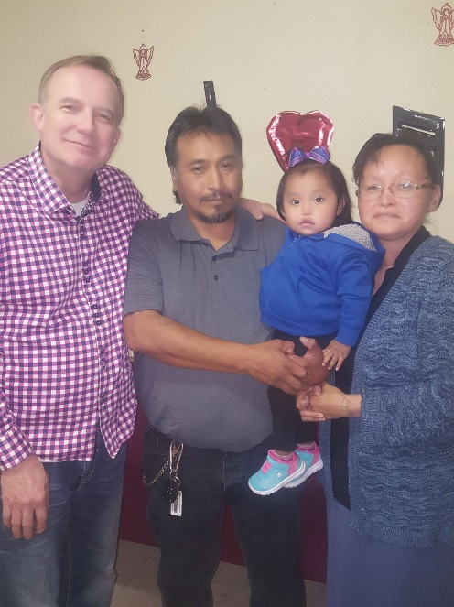
MIRACLE BABY

According to the doctors, this little girl should not have been born alive due to a lack of water in her mother's womb. This precious couple (Nathaniel and Terri Yardley) attended one of my services. God had me to lay hands on them and tell them that despite the doctor’s report their child would live and not die. Hallelujah! It was as God said, three months later Mrs Yardley gave birth to a healthy baby girl, at The Summit Medical Center. They named her Marianna. She is now two years old.
ARISE AND LIVE

I was shot in the back of the head and I was in a wheelchair for eleven years. I had twenty six brain surgeries and was scheduled for my twenty seventh. I went to a Wesley Van Johnson Healing and Miracle Crusade on a Friday night, Dr. Johnson called me out, laid hands on me and pulled me out of my wheelchair. I have been walking ever since. I had no need for a walker, crutches, canes or any type of walking aid. The Twenty Seventh brain surgery I was scheduled to have the following week in Florida was cancelled. According to man, I would never walk again, But God.
Bishop Levi Mcphee, Nassau Bahamas
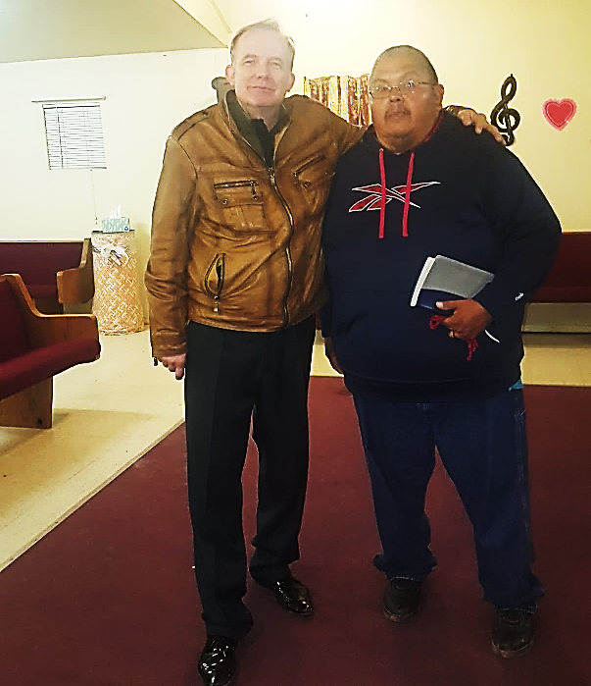
YOU WILL WALK AGAIN

I had open running sores on my right leg that would not heal. As a result I contracted an MRSA infection that went down into my bones. The Doctor said it was so serious, that they would have to amputate my right leg. Prophet Johnson laid hands on me and I was miraculously healed and the surgery to amputate my leg was cancelled. God is indeed a miracle worker.
Roger Clawson Jr. Whiteriver, Arizona

FROM DEATH TO LIFE

Acts20: 10-12
10 Paul went down, threw himself on the young man and put his arms around him. “Don’t be alarmed,” he said. “He’s alive!” 11 Then he went upstairs again and broke bread and ate. After talking until daylight, he left. 12 The people took the young man home alive and were greatly comforted.
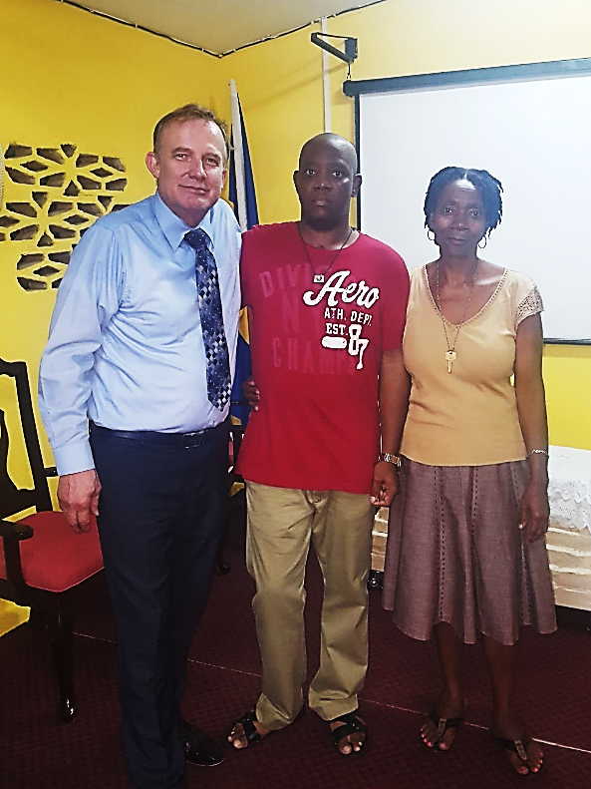

Due to a lack of oxygen, my Son Barry had to be placed on life support, during which time he suffered brain damage, stroke, cardiac arrest, and kidney failure.

The Doctors said Barry's organs were shutting down. They put him in a medically induced coma and gave him little hope of survival. It was during this time I attend a Healing Service at my Church with guest speaker Prophet W Johnson. He called me out and told me that God would raise him up, that he would live and not die.The Prophet gave me a prayer cloth and instructed me to place it on my son and Watch God. I did as instructed. I went into ICU where my son was laying in a coma on life support. I placed the prayer cloth on Barry's chest as Dr Wesley Jonson had said and my son woke up.
In just a few days after, he walked out of the hospital healed by the power of God.

Barry is an absolute walking miracle. According to Medical Science he should have been dead or be a vegetable and not be able to do anything for himself…. But God.

Mrs Bovell, Barbados
CREATIVE MIRACLE

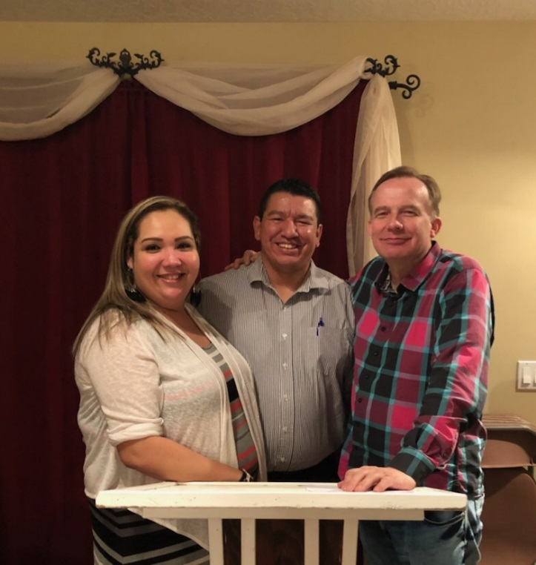
Ezekiel 37:7
So I prophesied as I was commanded. And as I was prophesying, there was a noise, a rattling sound, and the bones came together, bone to bone. (NIV)

My wife had a bad fall. As a result, her left shoulder was seriously injured and her left arm was broken. The Doctor said she would need a metal plate and screws in her left shoulder. They did not give us much hope of her ever being able to have full use of her left arm again. During a Wesley Van Johnson miracle crusade, Dr. Johnson told my wife, Ellen, that God was supernaturally fusing together the bones in her left arm and that it would be stronger than her right arm. When God was done healing her. Dr. Johnson then prayed and poured anointed oil into the cast.

For three days, my wife’s arm itched, we returned to the specialist who was to perform the surgery and he could not believe it, not only was the surgery no longer necessary, but her bones had fused together just like Prophet Johnson said they would. This all happened within two weeks of her fall. My wife received an absolute miracle and her left arm is now much stronger than her right one, just as God said it would be.
Pastor Kevin and Ellen Bigstone

My brothers and sisters, Faith is the Victory!

Become a Monthly Partner with
Dr. Wesley Johnson

As a Monthly Partner with Dr. Wesley Johnson, we (the ministry team and partners) have seen supernatural breakthrough.
WE BELIEVE YOU WILL HAVE: Supernatural Increase: Luke 6:38
Supernatural Favor: Proverbs 13:22.
Supernatural Health: Isaiah 58:8
Supernatural Wisdom and Financial Ideas to multiply your wealth: Deuteronomy 8:18.

Thank you for your prayers and financial support. Dr. Wesley Johnson

Please continue to support the ministry by making contributions through:
Interac e-Transfer at: drwj78@gmail.com
or request Bank Details for direct deposits or wire transfers.

We appreciate your continued financial support, which is very much needed. As you aid me in taking The Gospel to the world, I believe God will greatly bless you on every side.

Dr Wesley Van Johnson

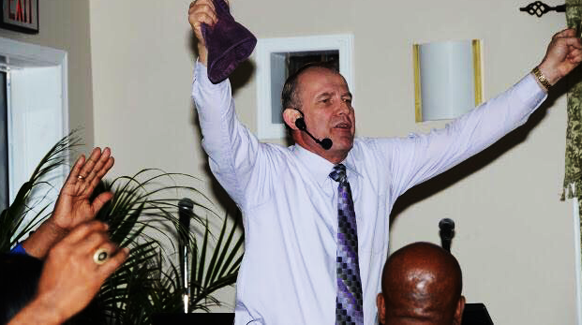
Seeing that faith is imperative for a victorious and successful life in the life of every believer, and that without faith it is impossible to please God; this comprehensive, Daily, Study Guide written by Dr Johnson, will indeed increase your understanding of this vast subject of faith and usher you to exceptional victories. As you follow the simple instructions given in this book, make the declarations given, receive, believe and act upon the Prophetic Words spoken by Prophet Johnson, you will go from Victory to Victory and experience supernatural breakthrough and blessings in every area of your life
Faith Is the Victory

About the Author

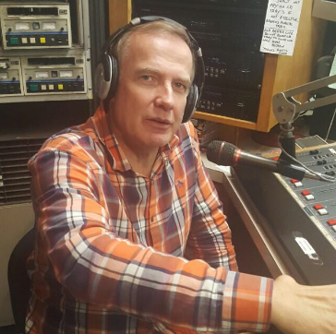
Wesley Van Johnson is a renowned Prophet, a dynamic speaker and lecturer. He is an ordained Bishop with the Pentecostal Church of God and has thirty-five years of ministerial experience. He is a leader and mentor and has a heart after God's own heart. Dr Johnson has a strong healing and deliverance ministry and multitudes have been blessed as a result. He has spent much time on radio and television and has held healing and miracle crusades in more than one hundred Countries. Bishop Johnson has established Churches on three Continents. He is a great asset and blessing to the Body of Christ. A Prophet is an anointed, humble man of God with great faith and has an awesome burden for souls. The hand of God and the favor of God, rests upon his life and Ministry.

